**SUPLEXA and the ENLIST Immune Cell Training Platform in Brief**

31 October 2024.

Every day, the immune system works to protect the body from various threats, including microbes and cancer. Despite its vigilance, cancer can evade detection and slip past its defenses. It does so by creating a suppressive microenvironment that hides it from the immune system, blunting a response that would otherwise eradicate it.

The ‘ENLIST’ immune cell training platform reawakens the immune system's natural ability to recognize and target cancer.

This innovative approach to cellular immunotherapy was envisioned by Alloplex Biotherapeutics Inc’s Founder and CEO, Dr Frank Borriello, in 2016:

* Instead of tweaking a single immune pathway, the ENLIST cell training platform harnesses multiple immune pathways to turn the tables on cancer.
* It does so by reinvigorating the immune system’s ability to recognize and attack cancer.
* The ENLIST technology platform was conceived for use in an autologous application, called ‘SUPLEXA’. However, the platform is also suitable for future Allogeneic ‘off-the-shelf’ approaches.
* The patient’s blood—immune cells and all— is taken from this ‘suppressive environment’ where they’ve become blind to the threat of cancer. They are retrained outside the body, in a controlled lab environment, to restore their ability to hunt out and destroy cancer.
* These reinvigorated cells are then reintroduced to the patient.

*“The ENLIST cell training platform represents a novel and unprecedented shift in immunotherapy”* says Dr. Borriello. *“We're not engineering cells; we're removing cells from a suppressive immune environment and retraining them to fight cancer more effectively than before”.*

*Further details available in Alloplex Biotherapeutics Backgrounder Q&A filer of 31 October 2024.*

**SUPLEXA in brief: how the process works**

* The surprisingly straightforward process begins with a simple 50 mL blood draw from the patient.
* 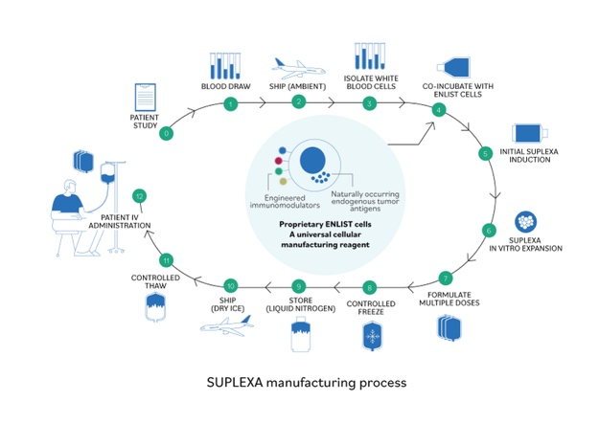Immune cells are then isolated and ‘trained’ ex vivo using Alloplex Biotherapeutics’ proprietary ENLIST technology.
* This training process, which takes about a month, revitalizes the cells and sharpens their ability to recognise and attack cancer.
* Once complete, the enhanced cells dubbed ‘SUPLEXA’ — in a nod to the wrestling move that flips an opponent into submission — are reintroduced into the patient, where they are better equipped to turn the tide on cancer.
* The lack of treatment related serious side effects is, perhaps, not surprising that the safety profile was so strong, given SUPLEXA is essentially the patients' own cells, restored to their original vigor and reintroduced into the patient to drive an anti-tumor immune response.

**First in human trial in Australia**

The first-in-human trial, which was designed to demonstrate safety and tolerability for this unprecedented approach, yielded clinical outcomes that have left doctors impressed.

*“The fact that we can actually get a clinical response and not just from a perspective of doing a CT scan and blood tests, but a clinical response with people getting back to normal life and excellent symptom control, is quite remarkable,” said the trial’s Principal Investigator, Assoc. Professor Rohit Joshi.*

* Trial participants were 35 late-stage patients with a variety of advanced cancers, including colorectal cancer, renal, melanoma, lung, and triple-negative breast cancer
* Every patient enrolled had been heavily pre-treated. They had exhausted all available standard treatment options.
* Broad efficacy, shown across multiple tumour types, including colorectal, renal, melanoma, lung, and triple-negative breast cancer, underscores SUPLEXA's potential to impact patient outcome across a wide spectrum of cancers.
* Colorectal cancer:
  + Notoriously hard to treat
  + Patients enrolled experienced remarkable clinical responses, with duration up to 2 years,
  + Improved pain management, improved quality of life.
  + No treatment related adverse side effects, unusual for a Phase 1 trial and a testament to the therapy’s innovative and personalized approach.

*“These are the kind of results that remind us why we’re doing this. Why we’re pushing the boundaries of what’s possible in cancer treatment,” said Dr. Borriello.*

**Summary**

* The results of the first trial offer a glimpse of what could be a new era in personalized cancer treatment.
* Alloplex Biotherapeutics has shown how its ENLIST cell training platform can reinvigorate the immune system, tipping the balance back in favor of its cancer-fighting instincts.
* While Alloplex’s first product, SUPLEXA, employs an autologous approach, the technology is compatible with Allogeneic
* *“With SUPLEXA, we're not just treating cancer; we're restoring the immune system's natural vigor. It's like giving the body's own defense forces a new lease on life in the battle against cancer,” Dr Borriello says.*
* This innovative approach could be the breakthrough that finally unlocks the full potential of immunotherapy, offering new hope in the fight to reduce the human toll of cancer.

Full press kit including Australian and Global media release versions, backgrounders, FAQs, downloadable graphics and photos are available from: [www.alloplexbio.com/presskitoct24](http://www.alloplexbio.com/presskitoct24)

Media contact: [media@alloplexbio.com](mailto:media@alloplexbio.com)